Capt Daniel Cook

Research Project: Added Effect of a Pitch Timer in Baseball

Abstract

This study uses a Differences in Differences model to show whether a PitchTimer increases a hitter's Batting Average. The population of interest is qualified hitters between 2015-2022. The response variable is the Batting Average, and the explanatory variables are the Year and the use of a PitchTimer. Batting Average = B0 + B1Year + B2PitchTimer + B3Year\*PitchTimer. Year\*PitchTimer is the parameter of interest and provides strong significance based on the P-value described below. Year\*PitchTimer provides a positive coefficient, suggesting a correlation between a PT and a higher BA. There is a direct and significant relationship between BA and PT. However, any conclusions about the significance level still need to be completed and require further research.

Introduction

Baseball is America's Pastime. Over the past century, the game's rules have only changed three times. In 1961, Major League Baseball (MLB) changed the season from 154 games to 162, and in that same year, Roger Maris broke Babe Ruth's record of hitting 60 home runs, but he had an additional eight games to do it which was a significant change. In 2008, instant replay started allowing on-field challenges, which could have changed the outcome of the World Series in 1985. In 2021, the Low-A (A+) West Division within Minor League Baseball (MiLB) began implementing a "Pitch Clock Timer" during the fifth week of the season with specific rules to help speed up Baseball games which had average game times of over 3 hours. In 2023, MLB began implementing the pitch timer rules used by the A+ MiLB, resulting in a decreased average of 28 minutes played per game. This paper uses a Differences-in-Differences (DID) model to show whether the PitchTimer affects variables other than time in the game. Specifically, does the PitchTimer increase the Batting Average of a hitter?

Data

The study population is A+ MiLB Batters who are qualified (have at least 123 at-bats per season) between 2015-2022. During 2021, A+ MiLB implemented a PitchTimer beginning in week 5 for the A+ West Division. The response variable is the Batting Average, the ratio of hits to official at-bats. An official at-bat excludes walks and when a pitch hits a batter. The explanatory variables are Year, measured in 20XX seasons; PitchTimer, measured by whether the game used a PitchTimer; and Year\*PitchTimer, explaining the effect on the PitchTimer over a MiLB season. A multiple regression attempted to determine whether there is an effect on the Batting Average due to implementing a PitchTimer.

Methods

Batting Average = B0 + B1Year + B2PitchTimer + B3Year\*PitchTimer

Batting-average (BA) is the Player's ratio of the number of hits per official at-bat. Year is the season surrounding games played between 2015-2022. B1 is the change in BA for a one-year increase in time. PitchTimer (PT) indicates whether the batter in the A+ MiLB league was in the A+ West (1) or in another A+ Division (0). B2 compares the population's BA with a PT versus those without a PT. B3 shows the effect a PT has on BA based on the Year. The multiple regression data and results are as follows:

Results

A population of 3,336 A+ MiLB Player Batting Statistics from 2015-2022 (Year) represented the data to conduct a multi-regression on the PitchTimer (PT) effect on BA. The overall BA for the data is .250. In other words, on average, from 2015-2022, players get a hit 1 out of 4 at-bats. Numerous regressions from the original data support the hypothesis of the positive correlation between PT and BA. Ultimately, the above model provided the most significant results, even after removing multicollinearity. For example, BB/K, the number of bases on balls per strikeout (K), were removed since using a PitchTimer could lead to increased walks, and BA will inevitably increase if K's decrease. Controlling for confounding variables would prove difficult, though future research will work to reduce them. There is a relatively low R-square of .0245, with the model explaining approximately 2.45% of the overall variance. The explanatory variables PT and Year have a negative correlation. The variable Year is relatively easy to explain, suggesting a downward trend in BA year over year. The PT variable suggests that using a PT decreases BA by the coefficient of -4.5411. However, data shows an overall downward trend in BA, which could be the causal explanation. Year\*PitchTimer is the parameter of interest and provides strong significance based on the P-value of 0.000883.

Moreover, the Year\*PitchTimer coefficient provides a positive coefficient of 0.002253, suggesting a correlation between a PT and a higher BA. In 2015-2019 data, results showed a higher BA in A+ West versus the other A+ Divisions by 1.24%, and between 2021-2022, BA for the A+ West was 7.84% higher. The model below visualizes the DID model explained above and summarizes data from 2015-2022:

Discussion

There is a direct and significant relationship between BA and PT. However, any conclusions about the significance level are incomplete and require further research. Open-source information supports the positive relationship between a player's BA and the use of a PT. However, there are only two and a half years of MiLB data on the topic, and limited datasets and information on MiLB rules prevent the ability to make any such conclusion definitively.

The data analysis phase of this research project data originally included 2023 statistics. The data presented below (2015-2023) summarizes the findings of the original data, though the explanatory variable of the PT was no longer isolated to the A+ West:

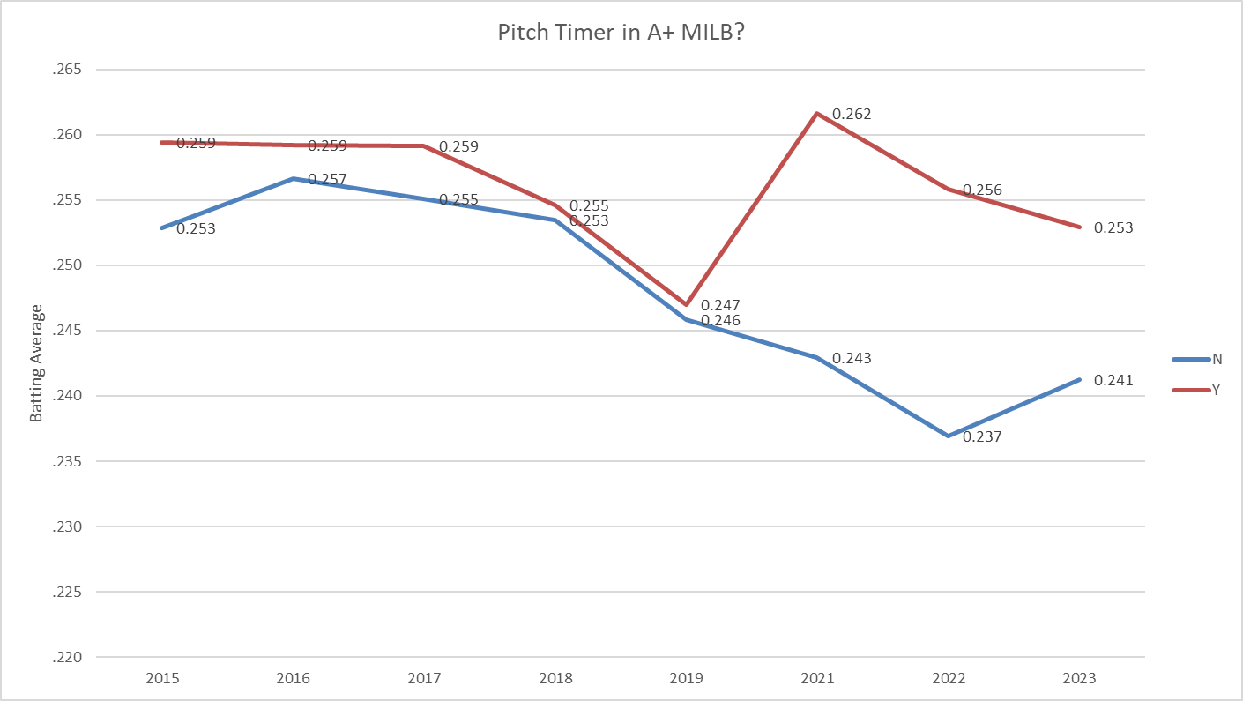

2023 shows a significant decline in PT and predicts the convergence of Y (PT) and N (no PT) due to a MiLB 2023 rule change, making the PT standard across the A+. The below table shows the regression data for the entire period of 2015-2023. Moreover, the A+ West collectively had a better BA across the entire timeline, which presents a possible confounding variable since the A+ West may have better hitters. Was the A+ West selected because they have better fields for pitch-timers? For example, the conditions of fields are likely functions of attendance and, thus, the talent of their players. Further research with MLB data will examine the relationship between a PitchTimer and a player's Batting Average.

References:

<https://www.rotowire.com/baseball/stats-minors.php>

<https://www.baseballamerica.com/stories/will-a-pitch-clock-actually-shorten-mlb-games-it-depends/>

<https://www.espn.com/mlb/story/_/id/35631564/2023-mlb-rule-changes-pitch-clock-end-shift-bigger-bases>